Early Stage Stationary List – P and F Supplied
To help busy parents and the school, this year the P and C association have put together the stationary lists from the school and packaged them up for easy ordering.
The Early Stage stationary pack for 2020 is available to order on QKR and will be delivered to the school in a box with your child’s name clearly marked.
What is included:
8 x Glue Sticks (2 per Term)
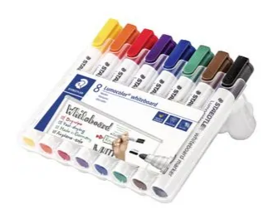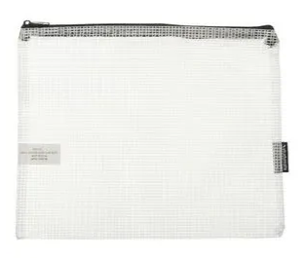
Plastic Folder 8 x Whiteboard Markers (2 per term) Home Reader Case

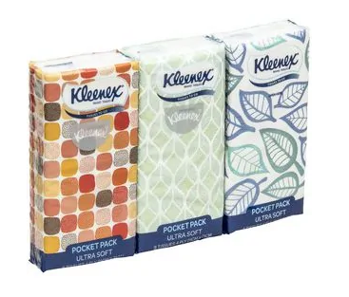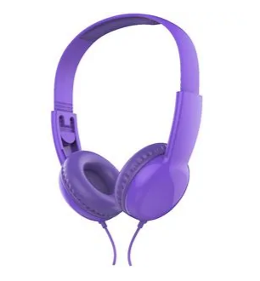
Packet of Tissues Fragrance Free Baby Wipes Child Headphones

What is not included:
- An old shirt for painting

Delivered to school in a box with your child’s name on
Only $65

Stage 1
To help busy parents and the school, this year the P and C association have put together the stationary lists from the school and packaged them up for easy ordering.
The Stage One stationary pack for 2020 is available to order on QKR and will be delivered to the school in a box with your child’s name clearly marked.
What is included:
8 x Glue Sticks (2 per Term)
5 x Clear Stud Folders
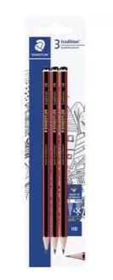
8 x Whiteboard Markers (2 per term) Pack of HB Pencils Pack of Coloured Pencils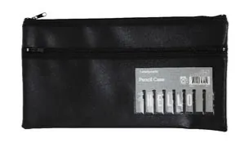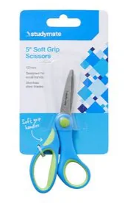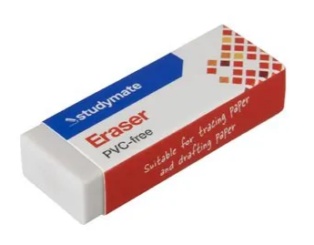
Small Pencil Case
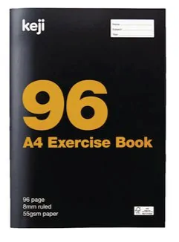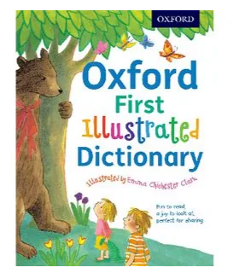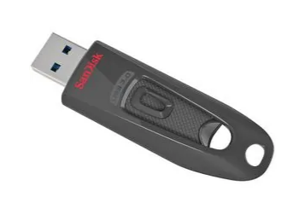
A4 Exercise Book Picture Dictionary Child Headphones 16Gb USB (School use)
Delivered to school in a box with your child’s name on
Only $95
Stage 2
To help busy parents and the school, this year the P and C association have put together the stationary lists from the school and packaged them up for easy ordering.
The Stage Two stationary pack for 2020 is available to order on QKR and will be delivered to the school in a box with your child’s name clearly marked.
What is included:
Pencil Case 2 x Glue Sticks Whiteboard Markers Red Pen
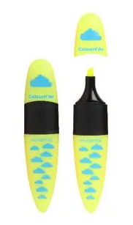
Pack of Pencils 2 x Highlighters Pencil Sharpener 2 x Erasers
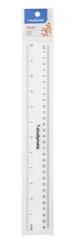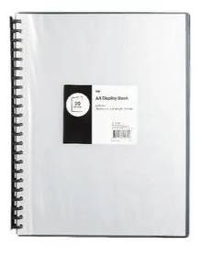
Child Scissors 30cm Ruler A4 Display Folder Homework Exercise Book
Child Headphones Box of Tissues Baby wipes

Delivered to school in a box with your child’s name on
Only $70
Stage 3
To help busy parents and the school, this year the P and C association have put together the stationary lists from the school and packaged them up for easy ordering.
The Stage Three stationary pack for 2020 is available to order on QKR and will be delivered to the school in a box with your child’s name clearly marked.
What is included:
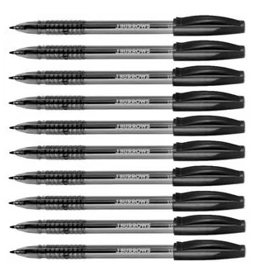
Pencil Case Pack of Pens Red Pen Pencils
Eraser Pencil Sharpener 2 x Glue Sticks Child Scissors Highlighters
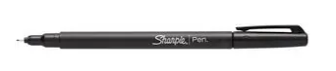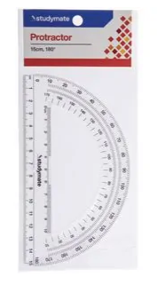
Whiteboard Markers Fine Point Sharpie Protractor 30cm Ruler Box of Tissues
3 x Clear Stud Press Folders A4 Display Folder Baby Wipes Child Headphones
Delivered to school in a box with your child’s name on
Only $85

